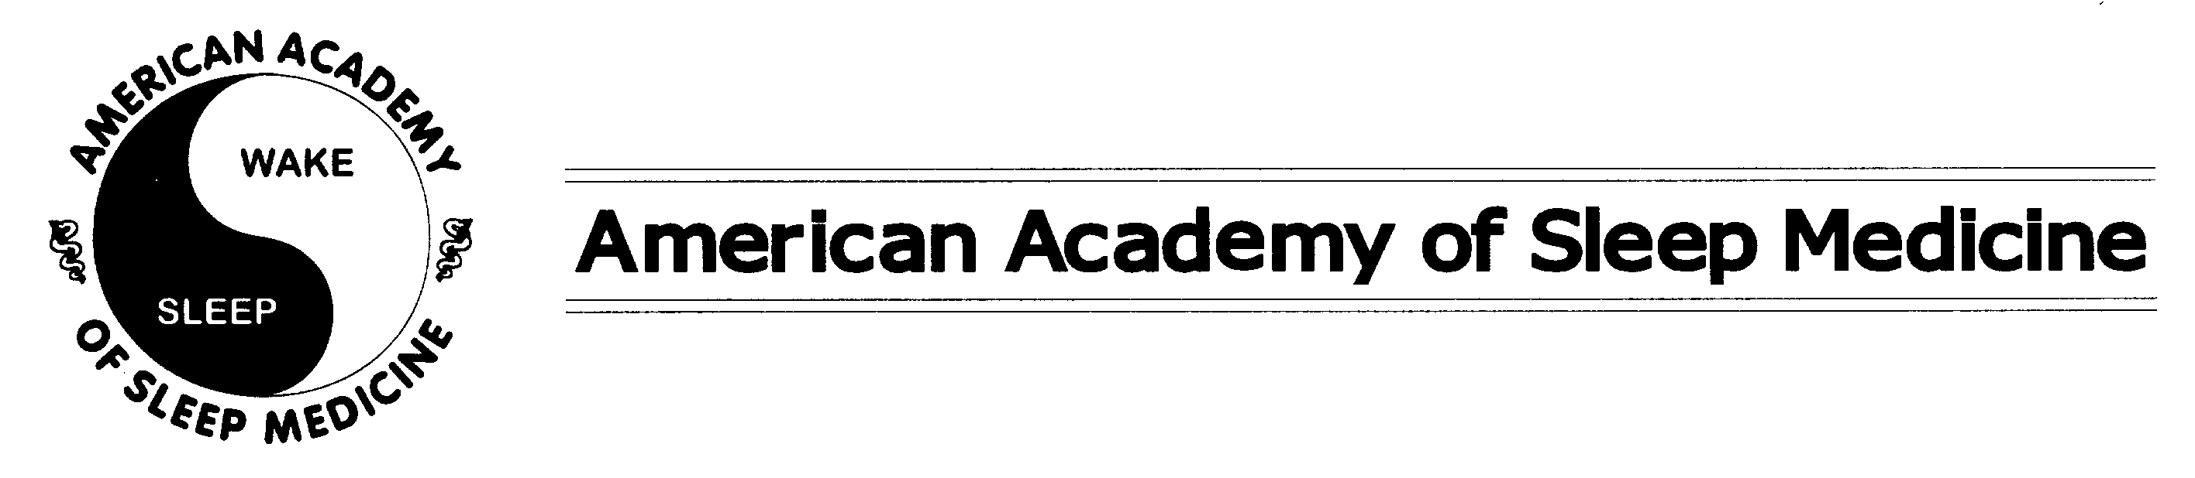
CONFLICT OF INTEREST DISCLOSURE
Please circle “YES” or “NO” for each question. If you answer “YES” to any questions, provide full details of all such arrangements, including the entity, type of activity and amount of compensation on a separate sheet.

Full Name: ____________________________________________________________________________

Institution: ____________________________________________________________________________

AASM Position: ________________________________________________________________________
1. | Do you hold membership in paid or unpaid (for profit) industry/corporate boards of directors or advisory boards related to sleep? | YES | NO
2. | Do you, your spouse or your children own stock in an individual company selling sleep products or services of greater than $10,000 but less than $25,000 (mutual funds or ownership of a sleep center by a practicing sleep physician is excluded)? | YES | NO
3. | Do you, your spouse or your children own either more than 5 percent of a company selling sleep products or services or stock in such a company of value greater than or equal to $25,000 (mutual funds or ownership of a sleep center by a practicing sleep physician is excluded)? | YES | NO
4. | Are you employed by manufacturers of sleep related diagnostic or therapeutic devices or medications, defined as 50 percent or more of total yearly non-investment income derived from such a commercial entity? | YES | NO
5. | Have you accepted payments for speaking engagements from industry within the last year or have contracted to accept such payments in the future (unrestricted educational grants excluded)? | YES | NO
6. | Are you a member of an industry speaker’s bureau? | YES | NO
7. | Have you received a personal gift valued at $250 to $500 provided by a sleep related business within the last year? | YES | NO
8. | Have you received a personal gift valued at greater than $500 provided by a sleep related business within the last year? | YES | NO
9. | Have you received discounted or free use of material or equipment of value greater than or equal to $250 provided by a sleep related business within the last year? | YES | NO
10. | Have you received a research or travel grant from a commercial entity within the last year? | YES | NO
11. | Have you received a research or travel grant from a governmental or not for profit entity within the last year? | YES | NO
12. | Do you serve on the board of directors or medical advisory board of a professional organization other than the AASM? | YES | NO
I have read the American Academy of Sleep Medicine Policy on Conflicts of Interest and certify that the information provided is current and correct and that I am in compliance with American Academy of Sleep Medicine policy.

Signature: _____________________________________________ Date: __________________

